# Solution Approach

We have developed a mini Fraud Detector system which will identity the transactions as anomaly fraud based on the score that the transaction gets via the different calculation that we perform based on the request.

There will a dashboard on which the agent can view the detected cases in UI which can future be taken into confirmation as confirm Fraud or False positive. This dashboard will try to get the transactions via API every 1 min if anything newly added.

## Assumptions

We have made couple of assumptions. Below are the listed of the same.

* UI screen loads transaction every 1 minute only if any new found.
* Input file Transaction id, Transaction Date Time will be changed based on execution date time.
* All inputs are in standard format only, no validations are applied on UI & CSV.
* Request origin other than India will be considered more score to match fraud transaction score 0.5
* Average Travelling Speed as 60km/Hr and max allowed additional difference is 1.5 time than avg speed.
* Transaction Average spending is less than current transaction amount then 1 score is added.
* Transactions Performed in 5 minutes on
  + Same card
    - More than 10, then 1 score; more than 5 then 0.5 score; more than 3 then 0.2 score else 0.1 score.
  + Same IP
    - Same logic of same card scoring
  + IP Fraud Transactions
    - If any previous fraud transactions performed on the IP, if more than 5 then score 1; if more then 1 then score 0.7 else 0;
  + Fraud IP List
    - If the IP exists in Fraud List and has attempts exists. More then 3 then score 1, more than 2 means 0.9 and more than 1 means 0.8
* If Total Score is >1.1 then we assume as IsFraud Case and show the entry in UI dashboard for agent to confirm the same.
* We just show the score in windows application as response of the input only for single request.

## Enhancements

We can make enhancement on the solution by

* moving all constants values to DB and make them configurable.
* Addition of more rule class possible by inheriting the interface.
* Once record is processed we can trigger a notification voice call, SMS, Email to customer to notify once the transaction crosses certain score.
* Addition of more information on UI for more details.

# How to Test

## Windows Application

Once we open the windows application we have 2 options.

### Batch Processing

We can upload the csv file which is placed in Inputfile\Input_5_26_2018_8_59_15_PM.csv

Click on file Upload and upload the csv. Once process is completed message box will be showed.

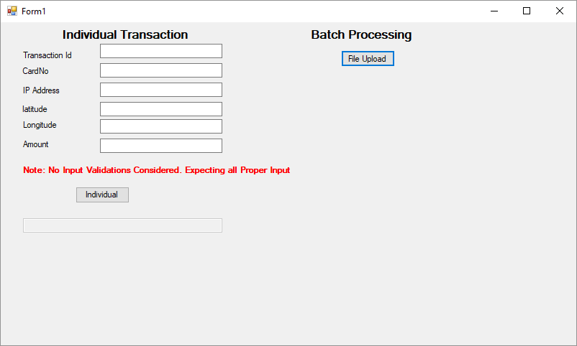

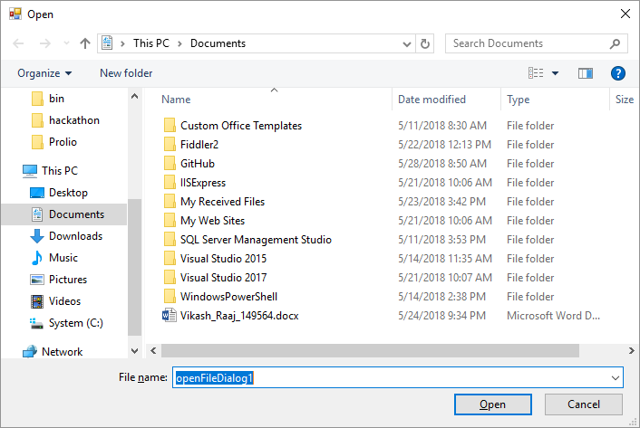

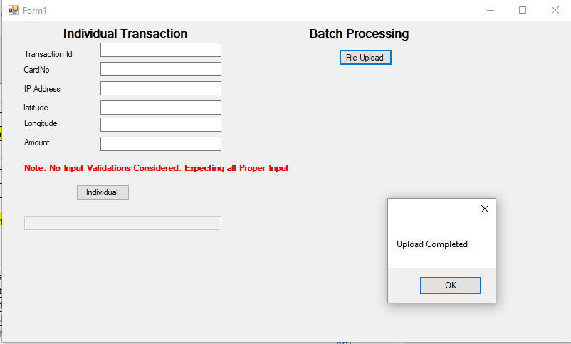

### Manual Individual Transaction

We can test an individual transaction also, this will help us to check the various combinations on IP address, latitude, longitude, amount against card no.

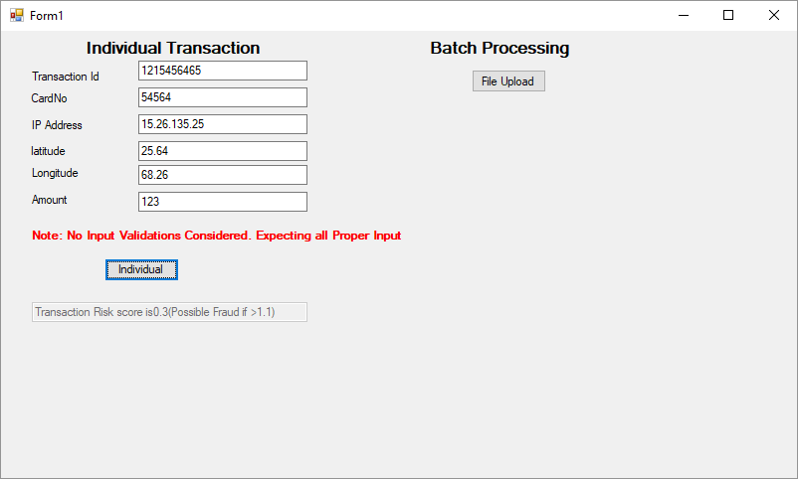

## Web Application (Dashboard)

The dashboard hosted in IIS will help to view the transactions that are system marked as fraud based on scoring pattern. As the user we can approve the transaction as fraud or false positive case.

[Home Screen]

### Processing a Detected Transaction

We need to click the button marked as per the below image.

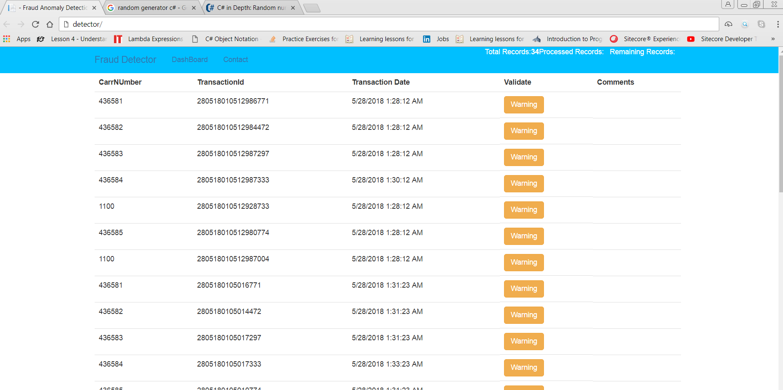

We get the below pop up screen on the UI

[POPUP screen shot]

Click the button to validate whether the transaction under false positive case

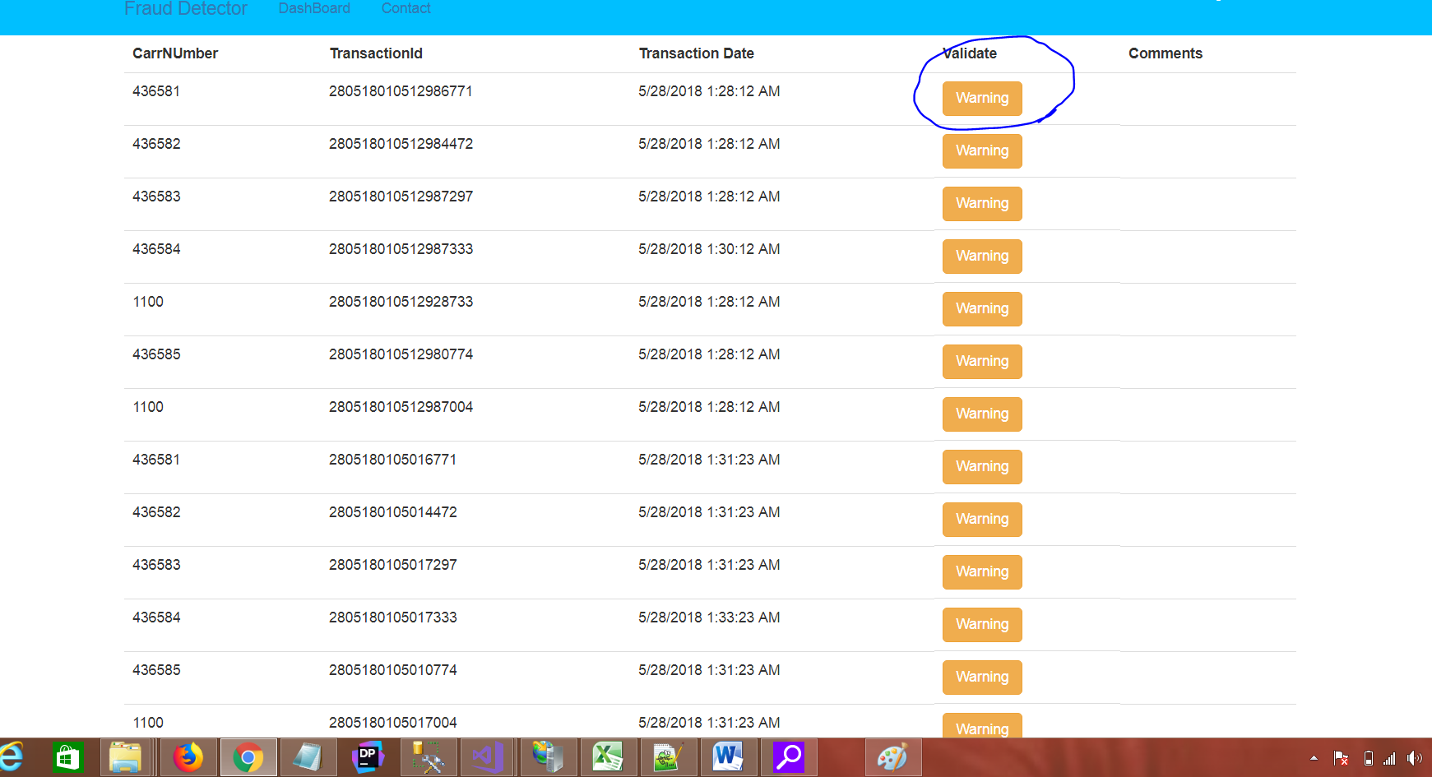

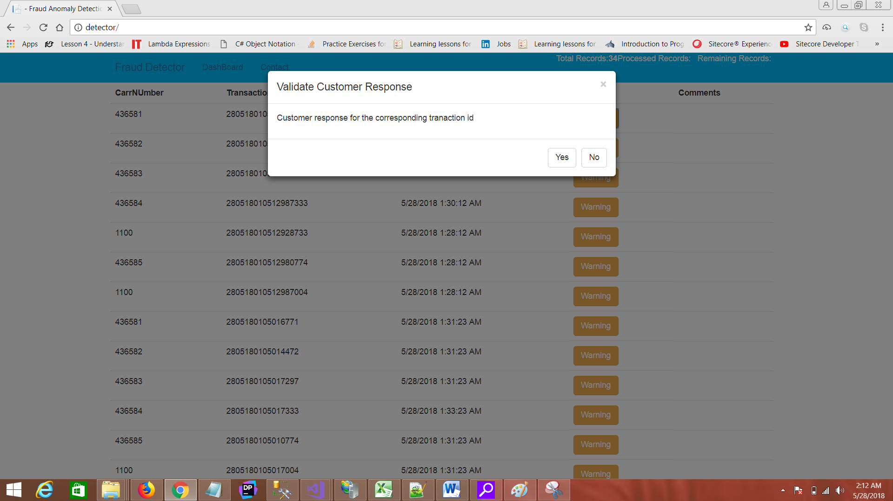

#### Fraud Confirmation Flow

Click on Yes and submit the pop up.

Check the color of the button changes and the comment has been added to the transaction

[for yes scenario home screen after popup close and add a red box to the button and comment to show case]

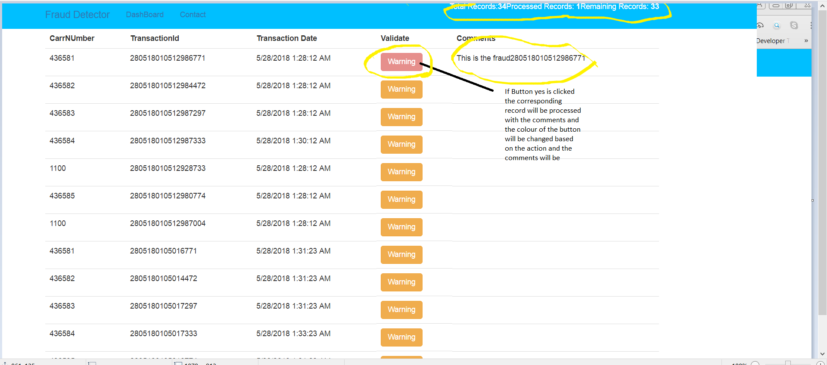

#### Fraud False Positive Flow

Take another record and click the button. Pop Up opens Click on No and submit the pop up.

Check the color of the button changes and the comment has been added to the transaction

[for No scenario home screen after popup close and add a red box to the button and comment to show case]

